**Reading: Try It! Change Pages Interactively**

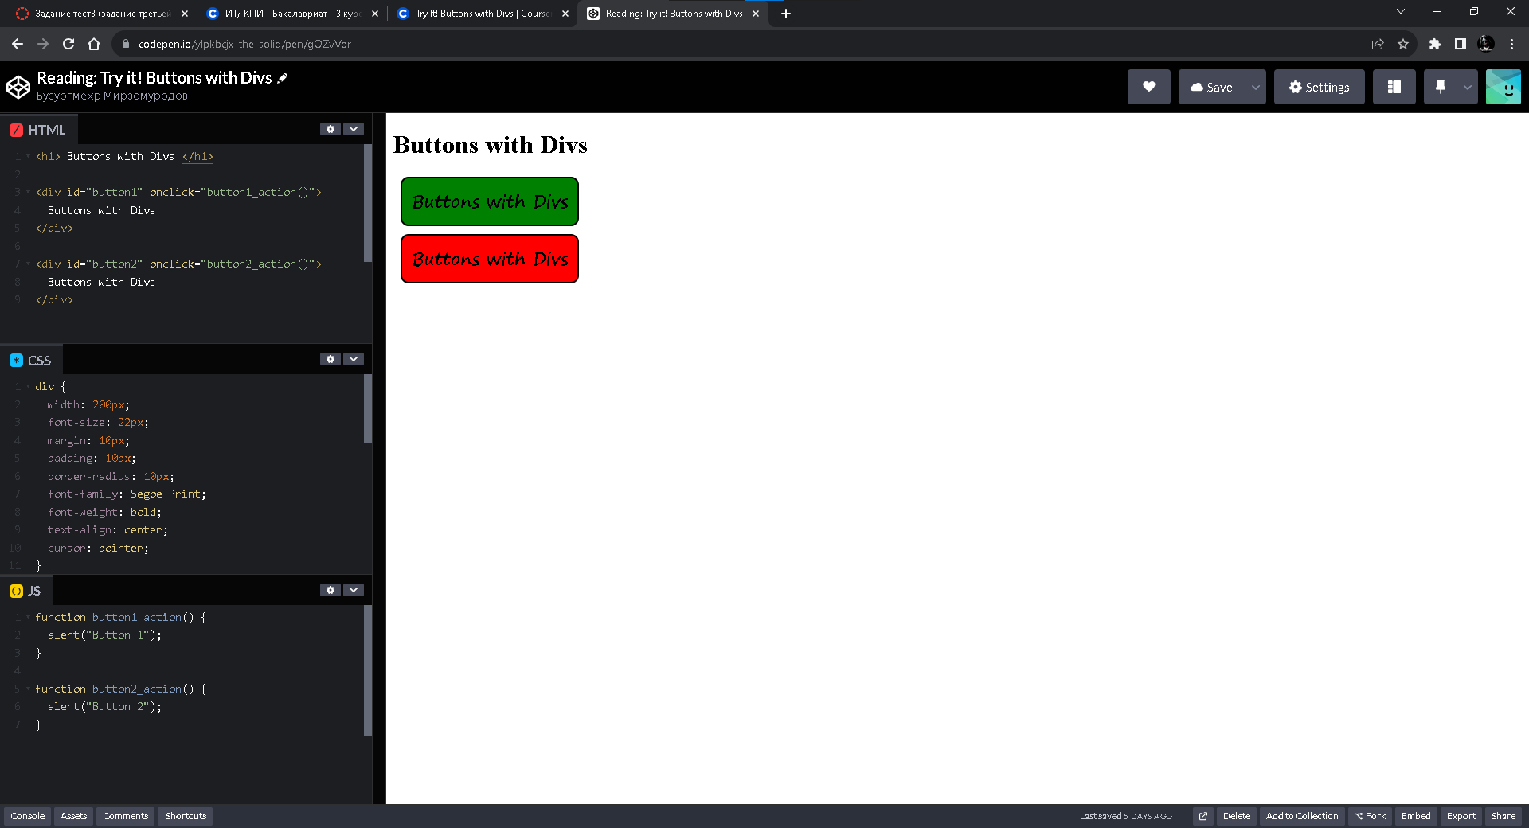

<https://codepen.io/ylpkbcjx-the-solid/pen/gOZvVor>

**Reading: Try It! Change Pages Interactively**

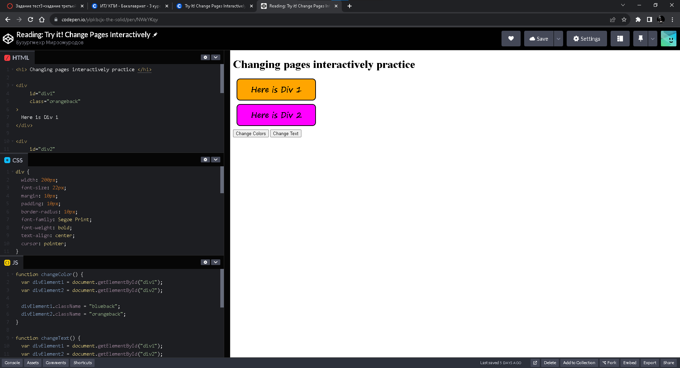

<https://codepen.io/ylpkbcjx-the-solid/pen/NWeYKqy>

**Practice Quiz: Buttons and Interactions**

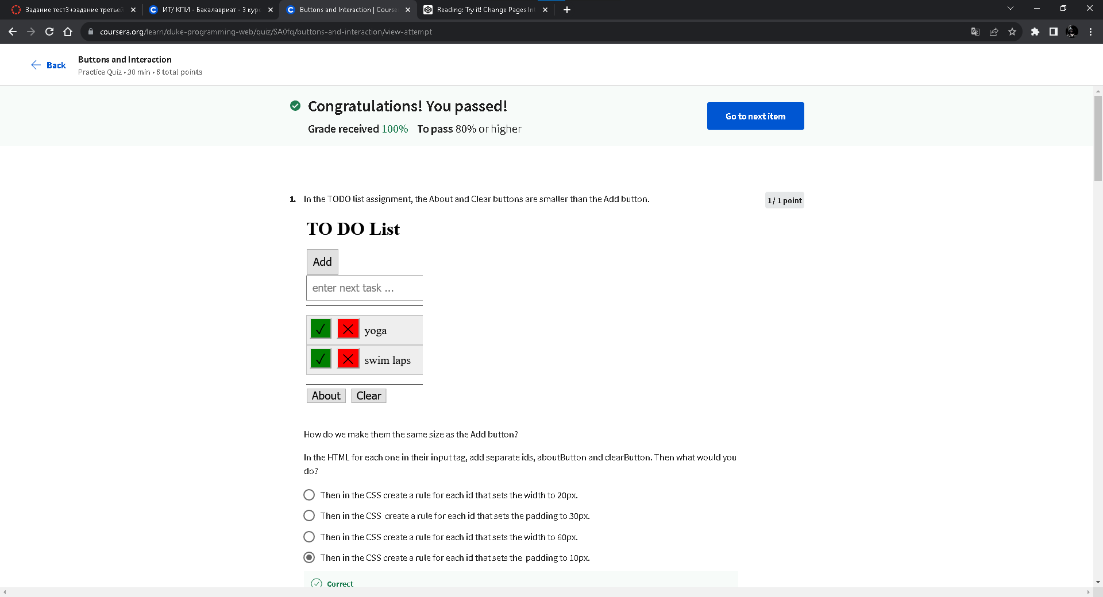

**Practice Quiz: Event-Driven Programming**

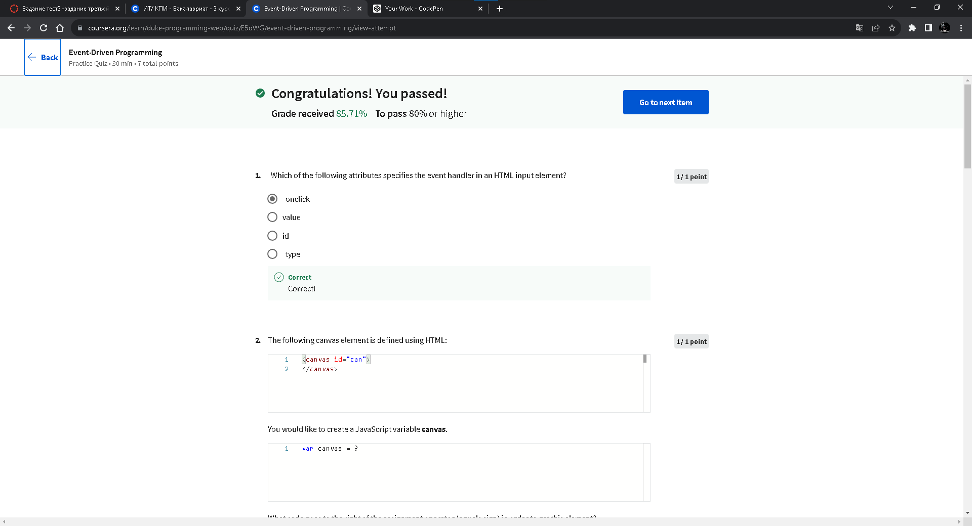

**Try It! Upload and Display an Image**

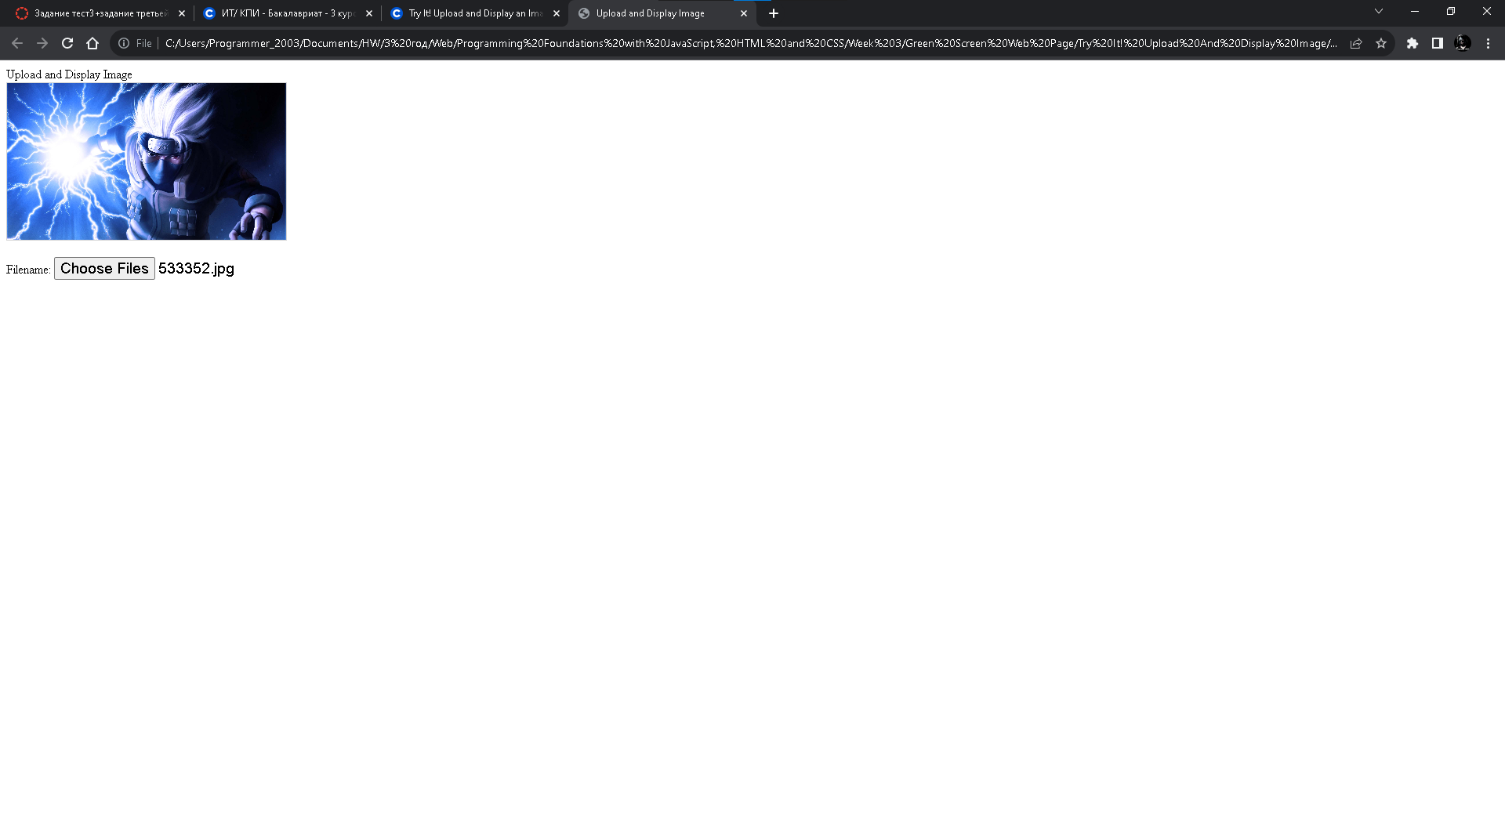

HTML:

<!DOCTYPE html>

<html>

<head>

<title>Upload and Display Image</title>

<link rel="stylesheet" href="style.css">

</head>

<body>

<header>Upload and Display Image</header>

<canvas id="can"></canvas>

<p>

Filename:

<!-- <input type="text" id="finput"> -->

<input type="file" multiple="false" accept="image/*" id="finput" onchange="upload()">

</p>

<script src="script.js"></script>

<script src="https://www.dukelearntoprogram.com/course1/common/js/image/SimpleImage.js">

</script>

</body>

</html>

CSS:

canvas {

height: 200px;

border: 1px solid lightgrey;

}

input {

font-size: 14pt;

}

JS:

function upload() {

var fileinput = document.getElementById("finput");

var filename = fileinput.value;

var image = new SimpleImage(fileinput);

var canvas = document.getElementById("can");

image.drawTo(canvas);

}

**Try It! Convert an Image to Grayscale**

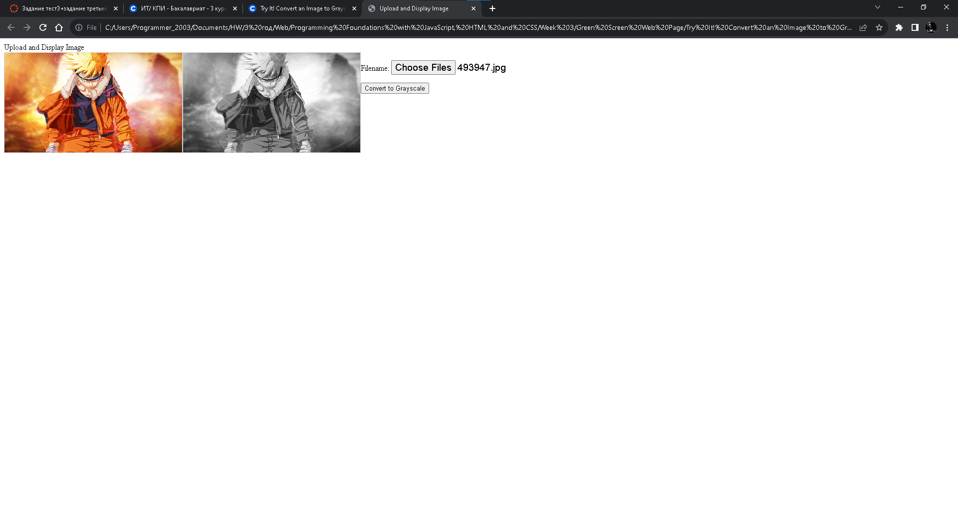

HTML:

<!DOCTYPE html>

<html>

<head>

<title>Upload and Display Image</title>

<link rel="stylesheet" href="style.css">

</head>

<body>

<header>Upload and Display Image</header>

<canvas id="originalCanvas"></canvas>

<canvas id="grayscaleCanvas"></canvas>

<p>

Filename:

<input type="file" multiple="false" accept="image/*" id="finput" onchange="upload()">

</p>

<button onclick="makeGray()">Convert to Grayscale</button>

<script src="script.js" charset="utf-8"></script>

<script src="https://www.dukelearntoprogram.com/course1/common/js/image/SimpleImage.js"></script>

</body>

</html>

CSS:

canvas {

height: 200px;

border: 1px solid lightgrey;

float: left;

}

#grayscaleCanvas {

float: left;

}

input {

font-size: 14pt;

}

JS:

var originalImage;

var grayscaleImage;

function upload() {

var fileinput = document.getElementById("finput");

var canvas = document.getElementById("originalCanvas");

originalImage = new SimpleImage(fileinput);

originalImage.drawTo(canvas);

// Reset the grayscale canvas

var grayscaleCanvas = document.getElementById("grayscaleCanvas");

grayscaleCanvas.getContext("2d").clearRect(0, 0, grayscaleCanvas.width, grayscaleCanvas.height);

}

function makeGray() {

if (originalImage) {

grayscaleImage = new SimpleImage(originalImage.getWidth(), originalImage.getHeight());

for (var pixel of originalImage.values()) {

var avg = (pixel.getRed() + pixel.getGreen() + pixel.getBlue()) / 3;

pixel.setRed(avg);

pixel.setGreen(avg);

pixel.setBlue(avg);

grayscaleImage.setPixel(pixel.getX(), pixel.getY(), pixel);

}

var grayscaleCanvas = document.getElementById("grayscaleCanvas");

grayscaleImage.drawTo(grayscaleCanvas);

} else {

alert("Please upload an image first.");

}

}

**Try It! Green Screen Online**

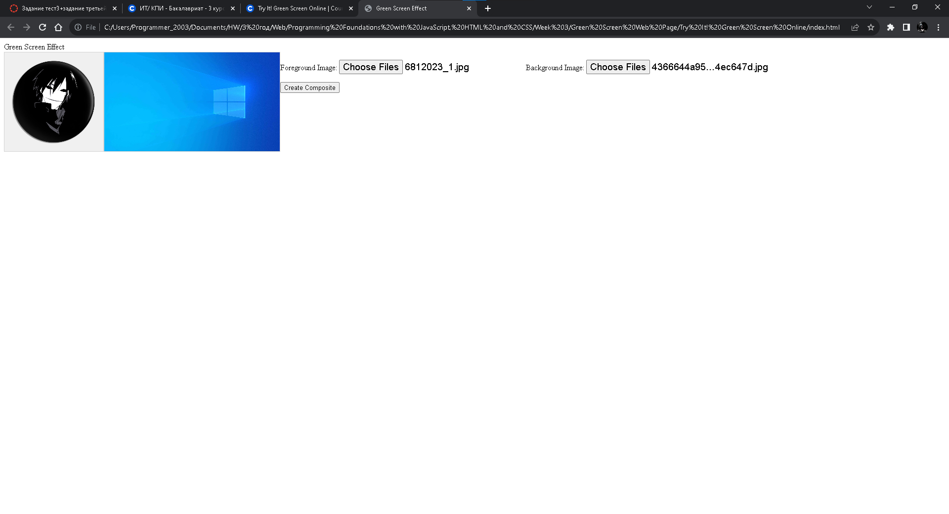

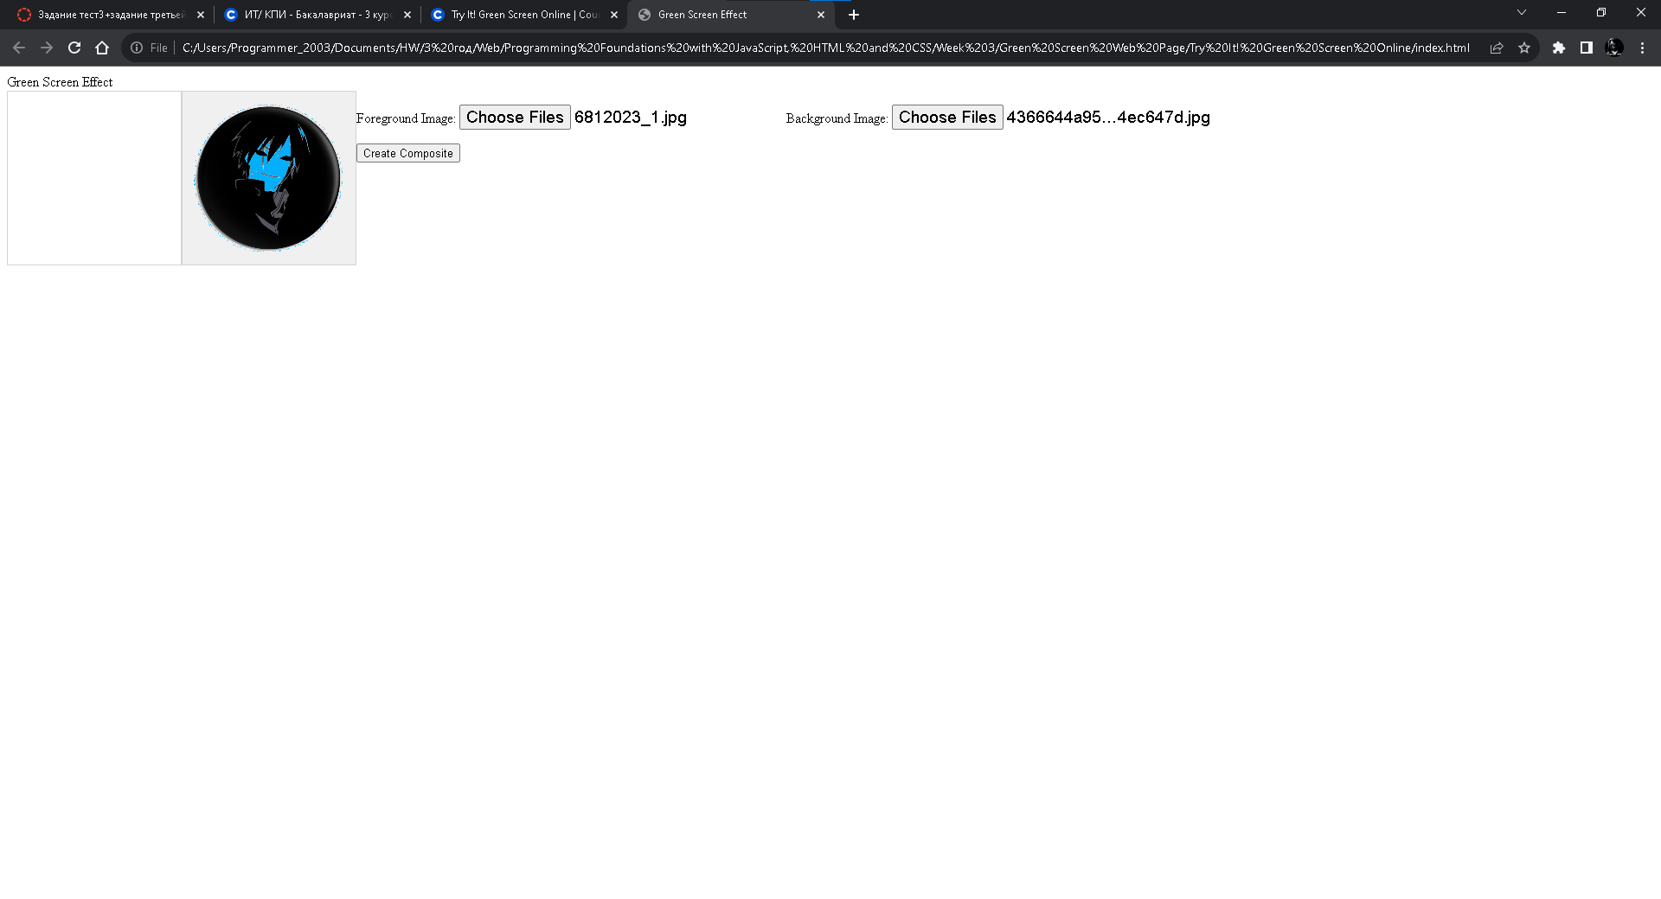

HTML:

<!DOCTYPE html>

<html>

<head>

<title>Green Screen Effect</title>

<style media="screen">

canvas {

height: 200px;

border: 1px solid lightgrey;

float: left;

}

#backgroundCanvas {

float: left;

}

input {

font-size: 14pt;

}

</style>

</head>

<body>

<header>Green Screen Effect</header>

<canvas id="foregroundCanvas"></canvas>

<canvas id="backgroundCanvas"></canvas>

<p>

Foreground Image:

<input type="file" multiple="false" accept="image/*" id="fgInput" onchange="uploadForeground()">

Background Image:

<input type="file" multiple="false" accept="image/*" id="bgInput" onchange="uploadBackground()">

</p>

<button onclick="doGreenScreen()">Create Composite</button>

<script>

var fgImage = null;

var bgImage = null;

var fgCanvas = document.getElementById("foregroundCanvas");

var bgCanvas = document.getElementById("backgroundCanvas");

function uploadForeground() {

var fgFileInput = document.getElementById("fgInput");

fgImage = new SimpleImage(fgFileInput);

fgImage.drawTo(fgCanvas);

}

function uploadBackground() {

var bgFileInput = document.getElementById("bgInput");

bgImage = new SimpleImage(bgFileInput);

bgImage.drawTo(bgCanvas);

}

function clearCanvas() {

fgCanvas.getContext("2d").clearRect(0, 0, fgCanvas.width, fgCanvas.height);

bgCanvas.getContext("2d").clearRect(0, 0, bgCanvas.width, bgCanvas.height);

}

function doGreenScreen() {

if (fgImage == null || !fgImage.complete()) {

alert("Foreground image has not been loaded.");

return;

}

if (bgImage == null || !bgImage.complete()) {

alert("Background image has not been loaded.");

return;

}

clearCanvas();

var threshold = 240; // Adjust as needed

var finalImage = new SimpleImage(fgImage.getWidth(), fgImage.getHeight());

for (var pixel of fgImage.values()) {

var x = pixel.getX();

var y = pixel.getY();

if (pixel.getGreen() > threshold) {

finalImage.setPixel(x, y, bgImage.getPixel(x, y));

} else {

finalImage.setPixel(x, y, pixel);

}

}

finalImage.drawTo(bgCanvas);

}

</script>

<script src="https://www.dukelearntoprogram.com/course1/common/js/image/SimpleImage.js"></script>

</body>

</html>

CSS:

canvas {

height: 200px;

border: 1px solid lightgrey;

float: left;

}

#grayscaleCanvas {

float: left;

}

input {

font-size: 14pt;

}

JS:

var originalImage;

var grayscaleImage;

function upload() {

var fileinput = document.getElementById("finput");

var canvas = document.getElementById("originalCanvas");

originalImage = new SimpleImage(fileinput);

originalImage.drawTo(canvas);

// Reset the grayscale canvas

var grayscaleCanvas = document.getElementById("grayscaleCanvas");

grayscaleCanvas.getContext("2d").clearRect(0, 0, grayscaleCanvas.width, grayscaleCanvas.height);

}

function makeGray() {

if (originalImage) {

grayscaleImage = new SimpleImage(originalImage.getWidth(), originalImage.getHeight());

for (var pixel of originalImage.values()) {

var avg = (pixel.getRed() + pixel.getGreen() + pixel.getBlue()) / 3;

pixel.setRed(avg);

pixel.setGreen(avg);

pixel.setBlue(avg);

grayscaleImage.setPixel(pixel.getX(), pixel.getY(), pixel);

}

var grayscaleCanvas = document.getElementById("grayscaleCanvas");

grayscaleImage.drawTo(grayscaleCanvas);

} else {

alert("Please upload an image first.");

}

}